Listed below is the ChatGPT dialog I used to create the html game, NCPDP Bingo. I used ChatGPT 5.1 in auto mode. The output of the ChatGPT session are the 2 other files in this repo:
- Bingo1.html
- ncpdp_bingo_caller_sheet.pdf

Contents
Query 1: please create a game called NCPDP Bingo. Have the bingo card be made of of NCPDP elements 1
Query 2: First make multiple, randomized PDF bingo cards 2
Query 3: the formatting came out real bad. The text didn't fit into the boxes. Please put each card on its own PDF page and make sure that the card looks good and like a real bingo card 3
Query 4: that was perfect. Now please make a playable browser game 3
Query 5: I am going to use it as an icebreaker. Will you please give me a list of items I can call out so we can play bingo? Put about 20 items in the list. I'll read these out 1 by 1 until someone in the call gets a bingo 4
Query 6: give me a longer, 50-item list on a printable caller sheet. And for each item, give me a funny way to call it out. 5

Query 1: please create a game called NCPDP Bingo. Have the bingo card be made of of NCPDP elements

Absolutely — here’s a clean, ready-to-use NCPDP Bingo card you can print or play with.
If you'd like an interactive HTML game, a PDF, or a multi-card generator, just say the word!

🎉 NCPDP BINGO (Version 1)
Below is a 5×5 bingo card filled with common NCPDP-related data elements, standards, transactions, and field names.

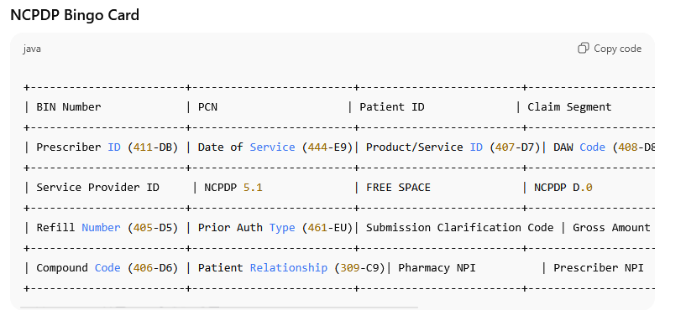

⭐ Want this as an actual playable browser game?
I can generate a full HTML file with:
- Clickable squares
- Randomized cards
- “BINGO!” detection
- Built-in NCPDP glossary popups
- Optional silly or humorous “NCPDP victory screen”
Just tell me:
A) Text-only bingo card is fine
B) Make it into a real web-based game (HTML/JS/CSS)
C) Make multiple randomized bingo cards for a team meeting
D) Make this into a printable PDF
What would you like next?

Query 2: First make multiple, randomized PDF bingo cards
Your multi-card randomized NCPDP Bingo PDF is ready!
📄 Download your file here:
👉 NCPDP Bingo Cards (PDF)
This PDF contains 5 unique, fully randomized bingo cards, each with:
- 5×5 layout
- Center “FREE SPACE”
- Only NCPDP-related fields
- Clean grid styling for easy printing
If you'd like:
✅ More cards (10, 20, 50, 100…)
✅ Cards with larger text
✅ Cards themed for a meeting or training session
✅ A version where each square includes a short definition pop-up (HTML)
✅ A multi-page PDF with instructions included
Just tell me!

Query 3: the formatting came out real bad. The text didn't fit into the boxes. Please put each card on its own PDF page and make sure that the card looks good and like a real bingo card

Your clean, professional NCPDP Bingo cards are ready!
Each card is now:
✅ On its own dedicated page
✅ Properly formatted with wrapped text
✅ Larger boxes (90×60 pts) so text fits cleanly
✅ Centered and aligned like a real bingo card
✅ Includes a shaded FREE SPACE
📄 Download your improved PDF here:
👉 NCPDP_Bingo_Cards_Clean.pdf
If you want:
🎨 A version with bigger boxes
🖨️ A printable 2×2 card layout per page
🌈 Color backgrounds
📚 A glossary sheet to accompany the cards
🎲 A random card generator you can run locally
Just let me know—I can produce any format you want!

Query 4: that was perfect. Now please make a playable browser game
Here’s a complete playable browser game for NCPDP Bingo 🎉
You can:
- Copy everything below into a file named ncpdp-bingo.html
- Open it in your browser
- Click “New Card” to reshuffle
- Click squares to mark them
- It will automatically detect BINGO (rows, columns, diagonals)

NOTE – that is a screenshot of the code below. The file, Bingo1.html, is a copy of that code.

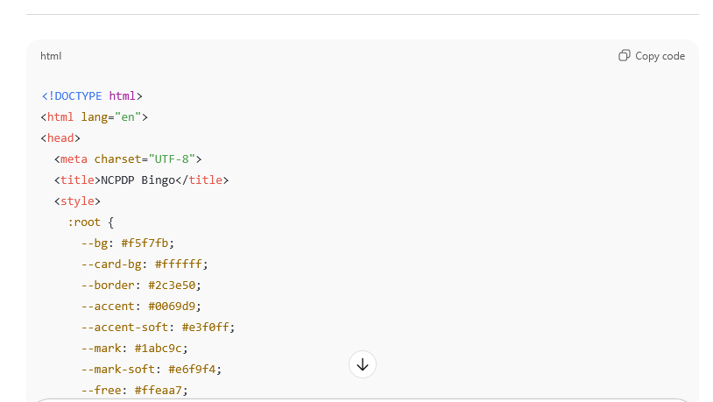

If you’d like, I can also:
- Add a “caller” mode that randomly draws NCPDP elements and shows a call history
- Add multiple cards on-screen for group play
- Track how many Bingos you’ve hit in a session
Tell me how you’re planning to use it (training, icebreaker, etc.), and we can theme it even more for NCPDP nerd fun. 🧠🧩

Query 5: I am going to use it as an icebreaker. Will you please give me a list of items I can call out so we can play bingo? Put about 20 items in the list. I'll read these out 1 by 1 until someone in the call gets a bingo

Absolutely — here’s a clean, fun NCPDP Bingo Caller List designed specifically for your icebreaker.
These are short, clear phrases you can read aloud one at a time.
They all map cleanly to items on the Bingo card.

🎤 NCPDP BINGO — Caller List (20 Items)
- BIN Number
- PCN
- Patient ID
- Claim Segment
- Transaction Code
- Prescriber ID — Four-One-One D-B
- Date of Service
- Product/Service ID
- DAW Code
- DUR / PPS Segment
- Service Provider ID
- NCPDP 5.1 Standard
- NCPDP D.0 Standard
- Coordination of Benefits
- Refill Number
- Prior Authorization Type
- Submission Clarification Code
- Gross Amount Due
- Patient Pay Amount
- Compound Code

If you'd like a longer list, a 50-item list, or a printable caller sheet, I can generate one instantly.
Also — if you want a little humor in the game, I can give you funny alternate ways to call each one, like "DAW Code — good luck explaining this to your mother-in-law."

Query 6: give me a longer, 50-item list on a printable caller sheet. And for each item, give me a funny way to call it out.

Your 50-item NCPDP Bingo Caller Sheet (with humor!) is ready 🎉
📄 Download the printable PDF:
👉 NCPDP_Bingo_Caller_Sheet.pdf
This sheet includes:
- 50 NCPDP-related items
- Each with a funny call-out line for your icebreaker
- Clean formatting
- Ready to print or screen-share
If you'd like:
✅ A color-coded version
✅ A version with checkboxes
✅ A second sheet with even funnier or darker pharmacy humor
✅ A sheet sized for 4×6 index cards (bingo caller deck!)
…I can generate that too!

